CSC8502 Coursework

Gokul Vinod Menon

210226568

Features Included:

• Present / Different means of rendering world geometry  
• Textured with at least one texture map

* Ambient lighting:
* Diffuse lighting
* Specular lighting
* Bump mapping on at least one object
* Skybox
* Reflection
* Automatic and Manual Camera Movement
* Scene graph used with cube robot
* Meshes used in screen
* Additional textures
* Blur effect
* Spotlight calculation
* Directional light
* Attenuation
* Transparent objects
* Use of advanced buffers
* Skeletal animation using vertex shader

Keybindings

* U – To switch to manual camera mode
* W,A,S,D – To manually move the camera around
* Shift – Traverse up using camera
* Spacebar – Traverse down using camera

Screenshots

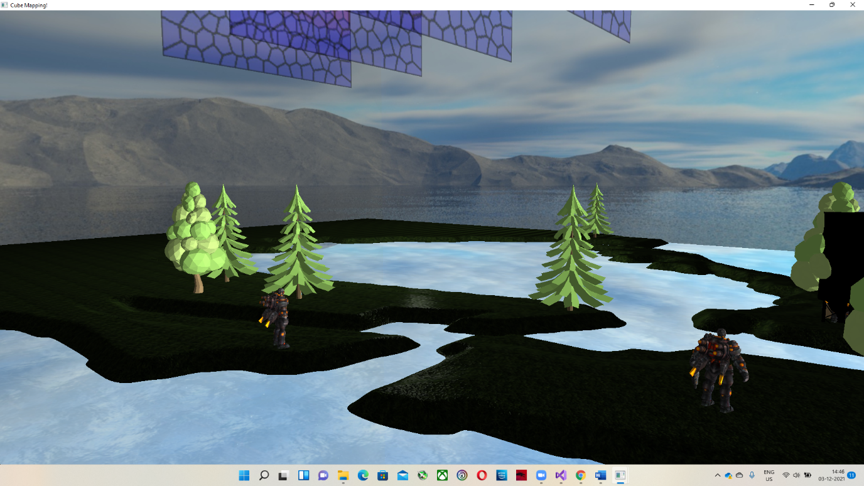

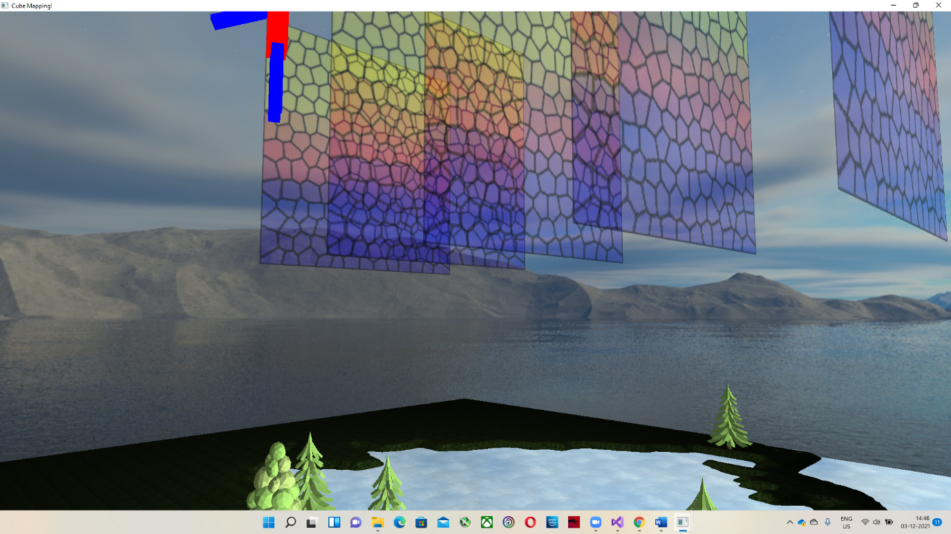

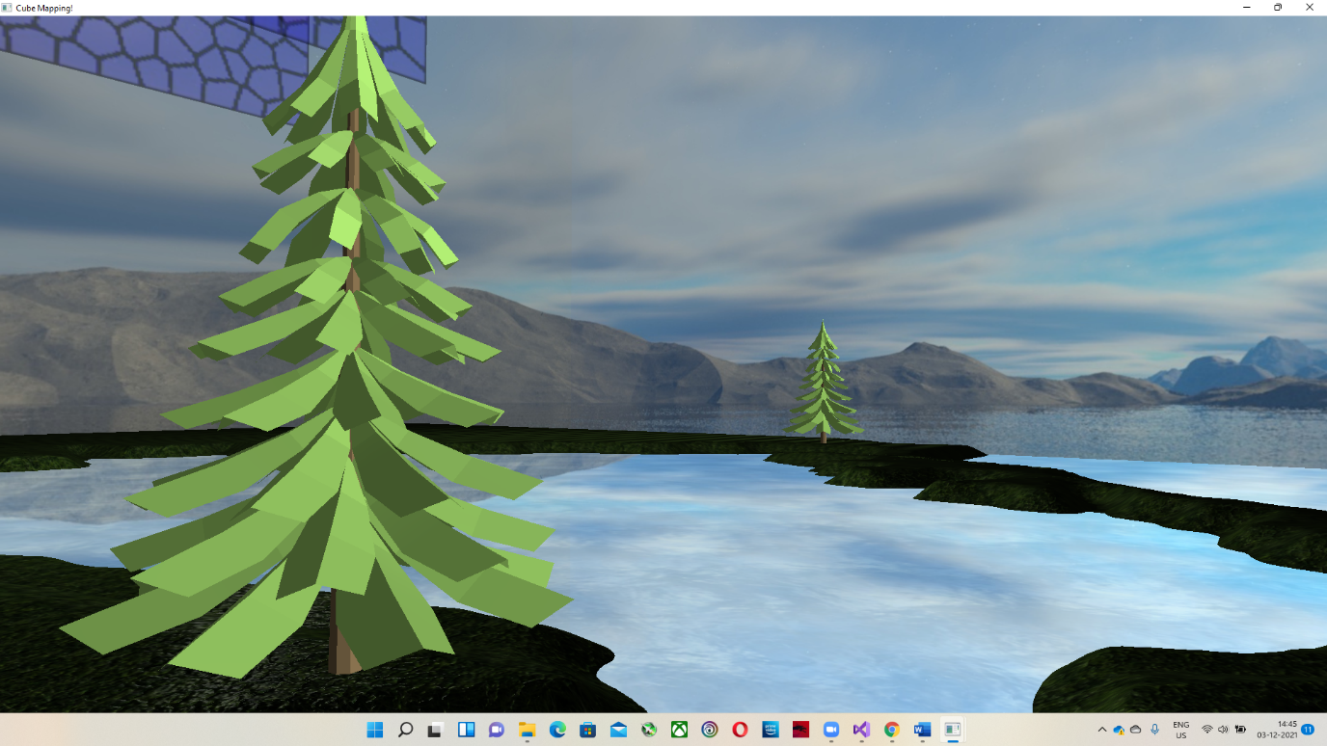

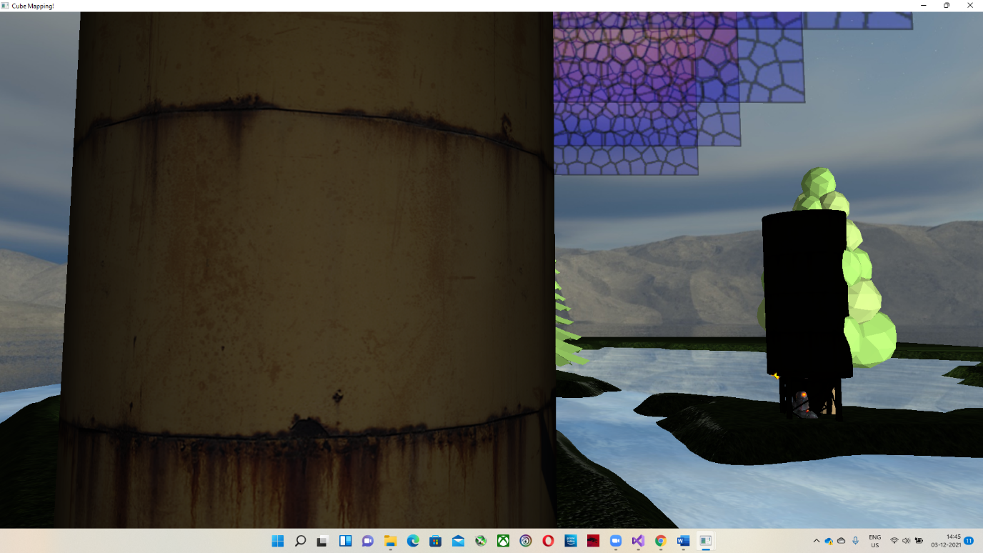

Video uploaded along with the zip file.